

**Western Australian Certificate of Education**

**ATAR course examination, 2017**

**Question/Answer Booklet**

12 PHYSICS

Name

**Test 3 - Moments and Equilibrium**

|  |  |  |  |  |  |  |  |  |  |  |
| --- | --- | --- | --- | --- | --- | --- | --- | --- | --- | --- |
| Student Number: In figures |  |  |  |  |  |  |  |  |  |  |

**Mark: ** In words

#### Time allowed for this paper

Reading time before commencing work: five minutes

Working time for paper: seventy minutes

**Materials required/recommended for this paper**

To be provided by the supervisor

This Question/Answer Booklet

Formulae and Data Booklet

***To be provided by the candidate***

Standard items: pens, (blue/black preferred), pencils (including coloured), sharpener, correction fluid/tape, eraser, ruler, highlighters

Special items: non-programmable calculators satisfying the conditions set by the School Curriculum and Standards Authority for this course

**Important note to candidates**

No other items may be taken into the examination room. It is your responsibility to ensure that you do not have any unauthorised notes or other items of a non-personal nature in the examination room. If you have any unauthorised material with you, hand it to the supervisor before reading any further.

**Structure of this paper**

|  |  |  |  |  |  |
| --- | --- | --- | --- | --- | --- |
| Section | Number of questions available | Number of questions to be answered | Suggested working time  (minutes) | Marks available | Percentage of exam |
| Section One:  Short Answers | 8 | 8 | 70 | 52 | 100 |
| Section Two:  Problem-solving | - | - | - | - | - |
| Section Three:  Comprehension | - | - | - | - | - |
|  |  |  |  | **Total** | 100 |

**Instructions to candidates**

1. The rules for the conduct of examinations at Holy Cross College are detailed in the College Examination Policy*.* Sitting this examination implies that you agree to abide by these rules.

2. Write your answers in this Question/Answer Booklet.

3. Working or reasoning should be clearly shown when calculating or estimating answers.

4. You must be careful to confine your responses to the specific questions asked and to follow any instructions that are specific to a particular question.

5. Spare pages are included at the end of this booklet. They can be used for planning your

responses and/or as additional space if required to continue an answer.

• Planning: If you use the spare pages for planning, indicate this clearly at the top of the page.

• Continuing an answer: If you need to use the space to continue an answer, indicate in the original answer space where the answer is continued, i.e. give the page number. Fill in the number of the question(s) that you are continuing to answer at the top of the page.

6. Answers to questions involving calculations should be ***evaluated and given in decimal***

***form*.** It is suggested that you quote all answers to ***three significant figures***, with the

exception of questions for which estimates are required. Despite an incorrect final result, credit may be obtained for method and working, providing these are ***clearly and legibly set out***.

7. Questions containing the instruction "estimate" may give insufficient numerical data for their solution. Students should provide appropriate figures to enable an approximate solution to be obtained. Give final answers to a maximum of two significant figures and include appropriate units where applicable.

8. Note that when an answer is a vector quantity, it must be given with magnitude and direction.

9. In all calculations, units must be consistent throughout your working.

1. Consider the following diagram below. A driver was required to change a flat tyre. However, the wheel nuts were too tight to loosen by hand and so the driver stood on the end of the torque wrench shown in the diagram.

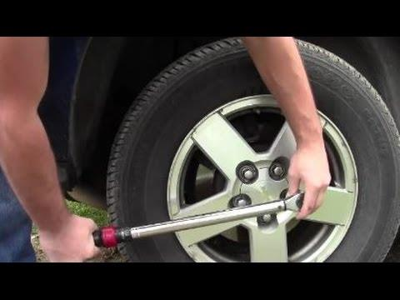

(a) ***Assuming that the wrench is horizontal***, estimate the torque applied to the wheel nut. Show your working clearly. [6 marks]

(b) Estimate the force applied to the wheel nut. Show your working clearly. [3 marks]

2. A bar of steel 80.0 cm long is pivoted horizontally at its left end, as depicted in Fig. 2.

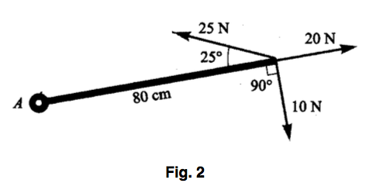

(a) Find the torque about A due to ***each of the forces*** shown acting at its right end.

[4 marks]

(b) Hence, determine the ***nett torque*** acting on the bar by the given forces. [2 marks]

 

3. The arm drawn in Fig. 3 supports a 4.00 kg sphere. The mass of the hand and forearm together is 3.00 kg and its weight acts at a point 15.0 cm from the elbow.

Assuming all the forces are vertical, determine the force exerted by the biceps muscle.

[4 marks]

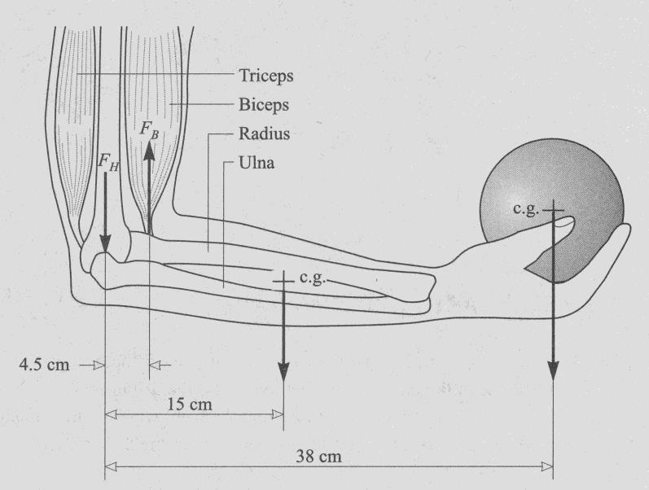

Fig. 3

4. A uniform rod AB of weight 1.00 x102 N and length 2.00 m is pivoted and balanced horizontally, and carries a load of 20.0 kg as shown in the diagram below. Determine the position of the pivot from end A. [4 marks]

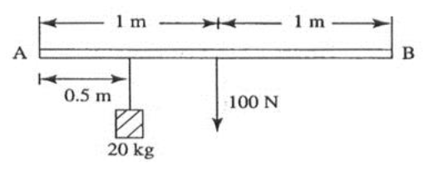

5. Where must a 0.800 kN object be hung on a uniform, horizontal, rigid 1.00 x 102 N pole,

2.50 m long, so that a girl pushing up at 0.250 m from one end supports one third as much as a woman pushing up at the other end? [6 marks]

6. Find the tensions in the ropes illustrated in Fig 7b below if the supported load of the bird feeder apparatus is 25.0 kg. Neglect the weight of the ropes.   [5 marks]

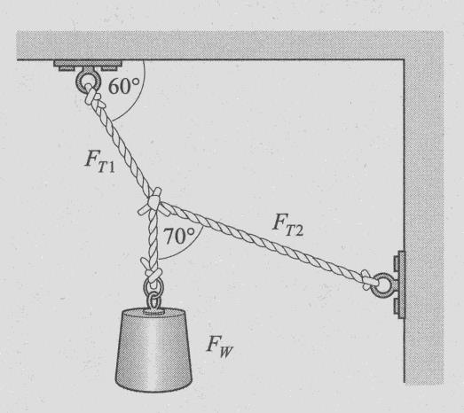 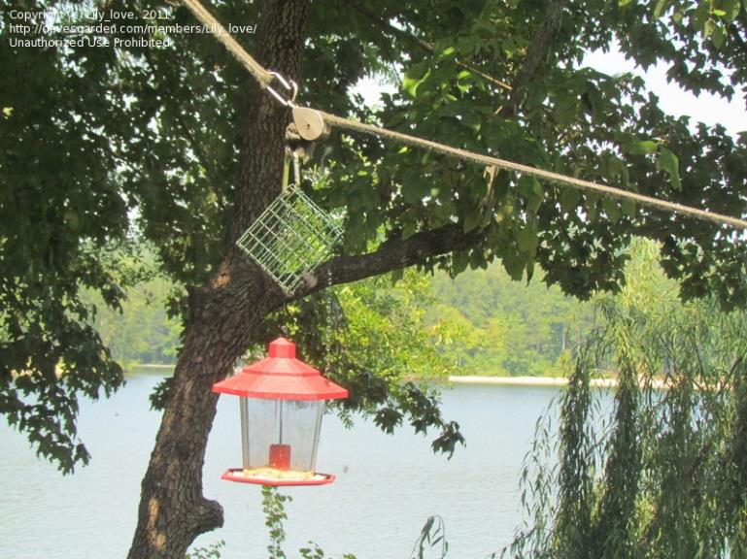

Fig 7b

7. A uniform plank shown below is 0.750 m long has a mass of M kg. It is suspended at an angle of 40.0° with the wall by a force of 50.0 N as shown below.

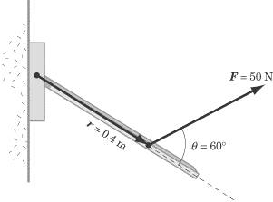

(a) Calculate the value of M. [4 marks]

(b) Calculate the magnitude and direction of the reaction of the wall at the hinge. Show this force on the diagram. [5 marks]

(c) If the force of 50.0 N were applied closer to the pivot, what would be the effect on your answer to (b)? Explain your reasoning. [3 marks]

8. The Figure 9A below shows an automated lifting system for use in the construction of tall buildings. The Figure 9B shows the base of the system.

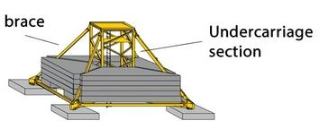

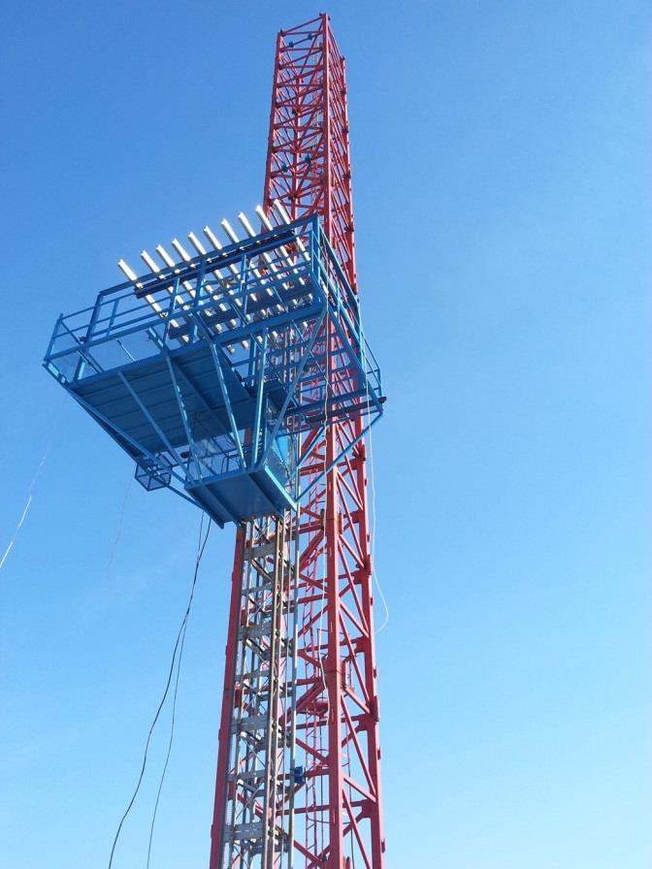

Figure 9A

(a) Briefly explain why the system become less stable as the building becomes taller.

[2 marks]

(b) Using a diagram, briefly explain the shape and construction of the base of the system. [4 marks]